13.3.7 Editors - Video Sequence Editor - Sidebar - Sequencer - View tab
Marker Options panel 1
Lock Markers 1
Sync Markers 1
View Options panel 1
Preview as Backdrop 1
Show Seconds 1
Sync visible range 1
Show Offsets 2
Show F-Curves 2
Cache 2
Show Cache 2
Final Images 2
Raw Images 2
Pre Process Images 2
Composite Images 2
Waveform Display 2
Show Markers 2

Marker Options panel
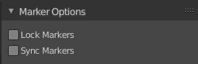

Lock Markers
Prevent marker editing.

Sync Markers
Transform markers with the strips.

View Options panel
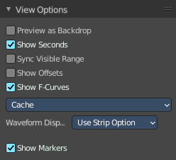

Preview as Backdrop
Display the result as a backdrop under the strips.

Show Seconds
Show the timing in the timeline area in seconds instead of frames.

Sync visible range
Synchronize the visible timeline range with other visible time based editors.

Show Offsets
Display strip in/out offsets.

Show F-Curves
Display the strip opacity/Volume curve.

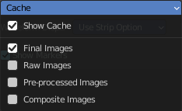
Cache
Cache settings.

Show Cache
Visualize cached images in the timeline.

Final Images
Show the final images.

Raw Images
Show the raw images.

Pre Process Images
Show the pre process images.

Composite Images
Show the composite images.

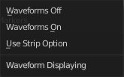
Waveform Display
How wave forms are drawn.

Show Markers
Display the markers menu and the markers at the bottom in the timeline.

